Attack Surface Analysis Example — WebHarvester (Web Crawler Project)

1. Project & Team Information
- Project name: PageHarvester
- Team members: O’Donovan Murphy II, Nikhil Patel, Omar Mountassir, Kevon Mair
- Course / Instructor: Dr. Zabihi
- Date: 4/26/26
- Version / Revision: v1.0

2. Executive Summary
PageHarvester is a program which autonomously parses a targeted Robots.txt file and downloads pages based on a search term entered by the user.
PageHarvester employs the following features:
- Configurable, in code, delay between server requests. Defaulted to 5 seconds.
- Verification of URL access rights, based on Robots.txt, prior to autonomous access.
- Targeted crawling
- Storage of crawled results

3. System Architecture Overview
- UML Diagram:
The software is comprised of two classes. Crawler and Logger. Crawler handles most of the heavy lifting while the logger class sends basic status updates to a log file.

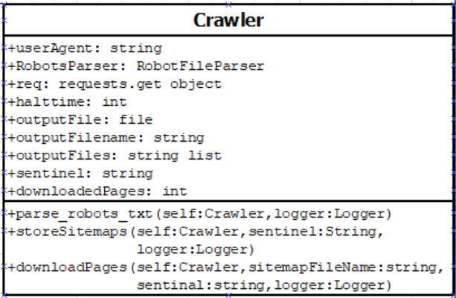

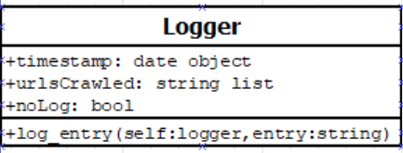

- Trust Boundary Diagram:
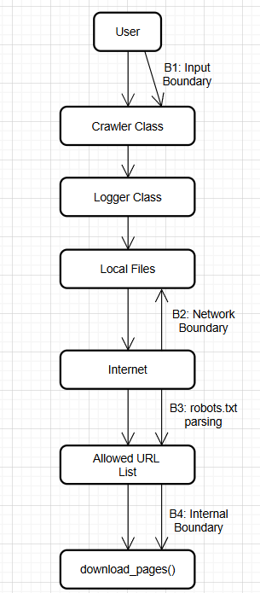

- Primary components:
  - Requests
  - Pathlib
  - Datetime
  - Time
  - Re
  - Sys
  - Urllib.robotparser

- Data flows:
  - Crawler class prompts user for a URL to crawl and a term to search for -> crawler.parse_robots.txt is called, if successful - > crawler.store_sitemaps is called.
    - Store sitemaps saves all xml files that are “allowable” and include the search term provided by the user. Crawler.outputFiles is incremented each time.
  - For each count of crawler.outputFiles crawler.download_pages is run. Storing html content of allowable and relevant pages.

4. Assets & Data Classification
Asset / Data | Owner | Description | Sensitivity (Low/Med/High) | Location
Raw HTML pages | Team/End User | Full downloaded pages | Low | ~/_pages/”sentinel term”/
Stored XML Files | Team/End User | Sitemaps containing allowed URLs | low | ~/_pages/”sentinel term” or ~/allowedSitemaps
Log file | Team/End User | Log file of operations | Low | ~

5. Trust Boundaries
Boundary ID | From | To | Crossing mechanism | Assets exposed
B1 | User | Input handler | Python input stream handling | Input stream, remaining processing.
B2 | Internet | End User’s Machine | HTTP Requests | Raw HTML Files, IP address, log file.
B3 | Robots.txt | Allowable URLs | RobotFileParser | Robots.txt, log file.
B4 | Allowed URL list | DownloadPages | Internal source code. | Filesystem, log file.

6. Attack Surface Components

A. Network
- External endpoints / ports: HTTP & HTTPS Requests ports 80 and 443.
- Outbound network: Software makes outbound requests to servers of users choosing.
- Protocols used: HTTP(S)
- Exposed services: OS, networking drivers, ports

B. Software (Applications & APIs)
- Crawler code / frameworks: requests, pathlib, datetime, time, re, sys, urllib.robotparser
- APIs & endpoints: N/A
- File handling: Raw HTML and XML blobs are saved as ASCII files with the appropriate exention.
- Third-party integrations: N/A

C. Human (Users & Administrators)
- Roles & privileges: End User
- Interfaces that accept input: User input for robots.txt target and search term.
- Authentication: N/A
- Human errors: User could run multiple instances of the script and violate the 5 second delay.

D. Execution environment (OS, containers, middleware)
- OS & versions: OS Agnostic. Should run on any machine with a Python interpreter
- Containers: N/A
- Middleware & runtime: N/A

E. External dependencies (libraries, APIs, frameworks)
- Libraries: N/A
- External services: N/A

7. Threats & Attack Vectors (mapping)
Component | Element | Threat / Attack Vector | Potential Impact | Likelihood
Human | User Input | Someone could use the script to connect to a page that could be banned through their admin browser settings. | Violation of sysadmin policy | Low
Robot.txt parser | Parsing Robots.txt file | A malicious robots.txt could be hosted that is intentionally large and unable to be parsed. | Extreme memory usage and wasted CPU cycles | Low
Storage | Raw HTML & XML storage | Accidental storage of malicious or protected data. | Data leak, compliance violation, security risk | Medium
Environment | Dependencies | A vulnerability could exist in urllib.robotparser. | Exposure to outside attacks to end-user machines | Low-Medium
Network | IP blocking | Target sites block crawler IPs, or CAPTCHA challenges | Blacklisting from certain sites. | High

8. Attack Surface Summary Table
Exposure | Why it matters | Severity (1–5) | Remediation priority
Outbound fetches to untrusted hosts | Direct interaction with attacker-controlled servers | 5 | High
Raw HTML store that may malicious or protected data | Legal / privacy risk | 2 | Low
No vetting of 3rd party library uses with respect to security | Exposes the end-user to possible vulnerabilities. | 5 | High

9. Lessons Learned & Future Work
Parsing the robot.txt file from scratch is much more involved than originally anticipated. It also became obvious early on that many, if not most, are very restrictive when it comes to testing a webcrawler.
Future work would involve:
- Better error handling
- GUI
- Customizable pathing for storing crawled data
- MYSQL Database integration

10. Revision Log
- v1.0 — 2026 4/26/26 — Converted example to PageHarvester (crawler) project

Instructor Checklist (for grading)
- Diagram annotated with trust boundaries
- Inventory completed for network, software, human, execution environment, external dependencies
- At least 5 mapped threats with impacts and likelihood

